**Instructions for running automation test suite**

1. Introduction:

This is a framewrok automation which written in Java + selenium + testNG and using page object model. There will be one testNG file that contains all test cases about BookingSG services.

The project structure include these main folders:  
*Core: this folder contains the foundation of all test cases

*Page: this folder contains all page objects and functions or actions

*Test: this folder contains all test cases to run in test suite

*Utility: this folder contains configuration class to grab and insert data at excel file

1. Requirement:

- Java SE Development Kit 11.0.21: <https://www.oracle.com/java/technologies/javase/jdk11-archive-downloads.html>

- Scoop: open your Powershell and run:  
**Set-ExecutionPolicy** -ExecutionPolicy RemoteSigned -Scope CurrentUser

Then   
**Invoke-RestMethod** -Uri https://get.scoop.sh | **Invoke-Expression**

- Allure: in Powershell, run : scoop install allure

- Latest version of IntelliJ IDEA Community: <https://www.jetbrains.com/idea/download/other.html>

1. Implementation

* Unzip project file



* Open IntelliJ IDEA Community then open project using “Open” button:  
  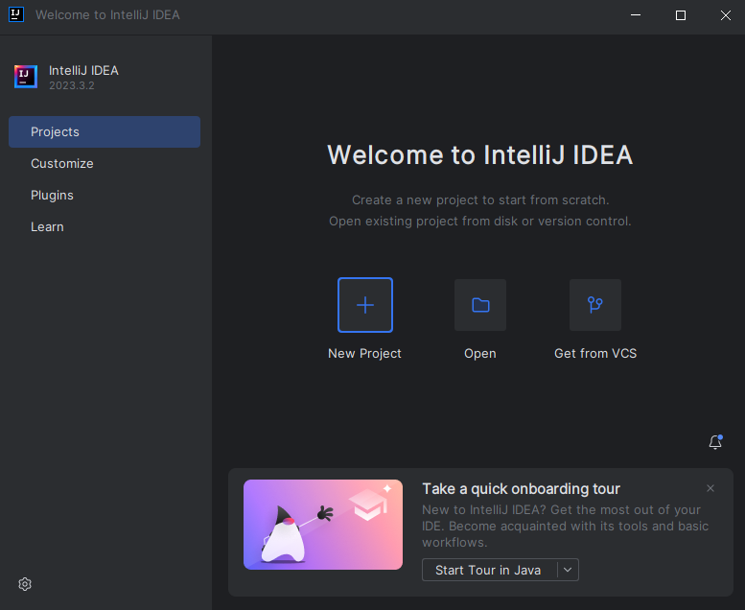
* Navigate to the project destination and select “OK” button:

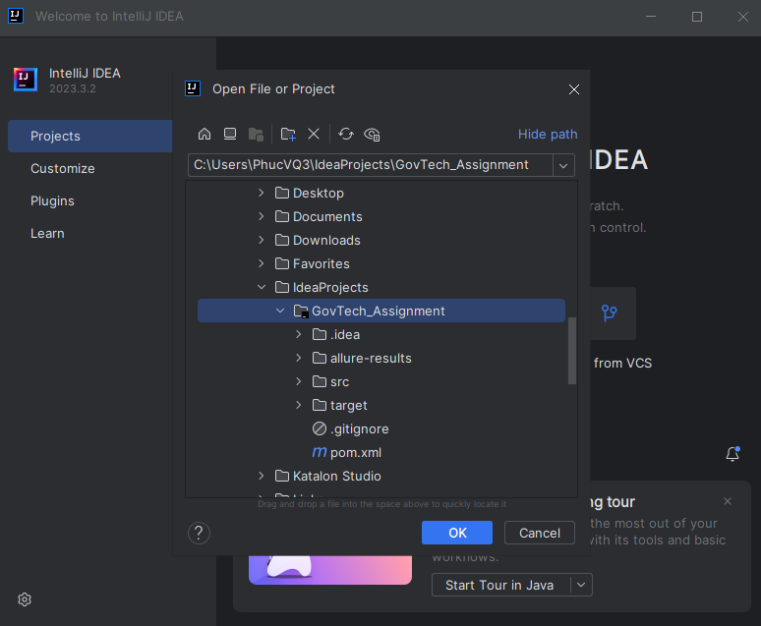

* Make sure to select “Trust Project” button, then wait after IntelliJ IDEA finishes configuring all necessary settings
* Open project folder structure

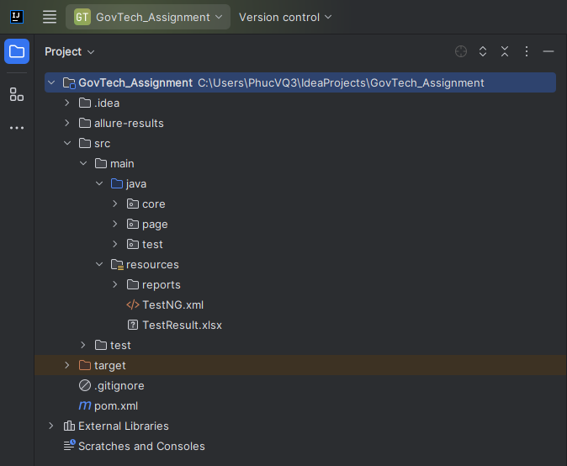

* Right click on the “TestNG.xml” file, select “Run...” following the highlight line:

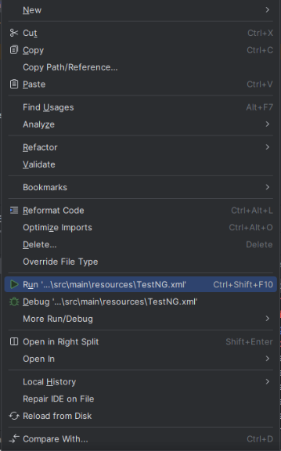

* Wait for all test case done running in that test suite, the result will appear on console:

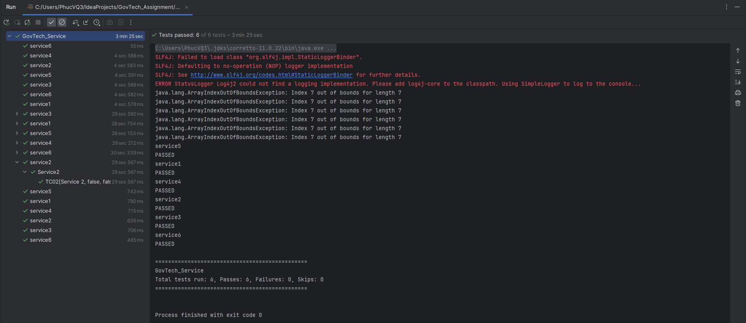

* To see the detail of the results, open the in-app terminal and run : allure serve

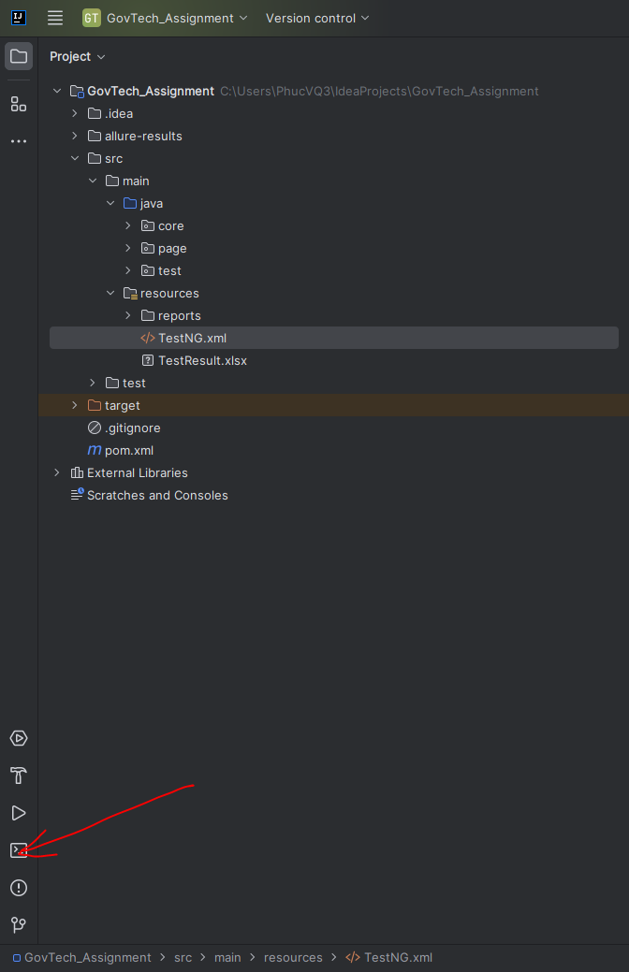

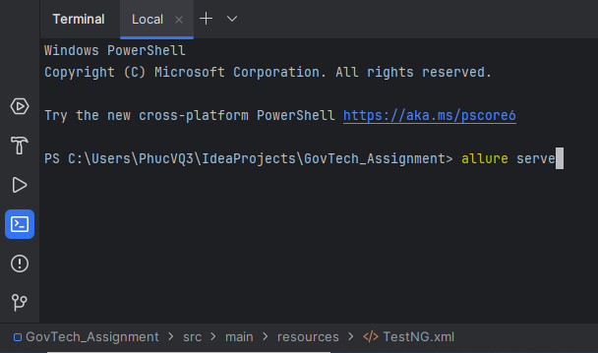

* The report page will be display on the browser:

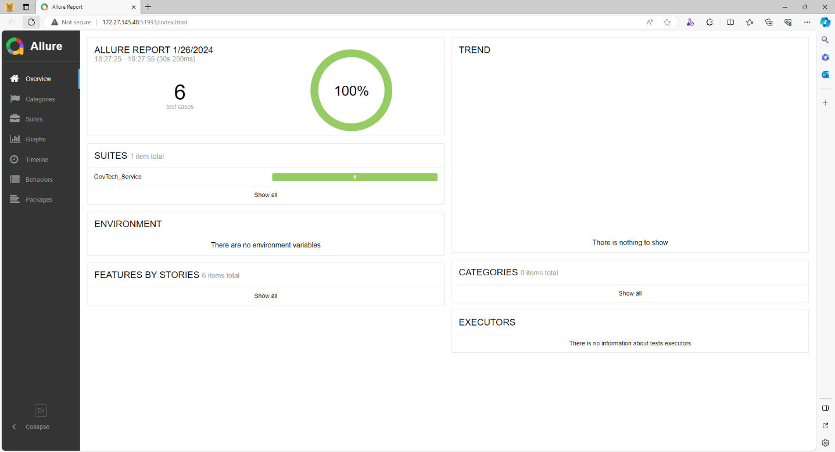

In case you want to view it manually, go to folder resources -> reports -> open excel file ( the lastest running result will always be the bottom file )

